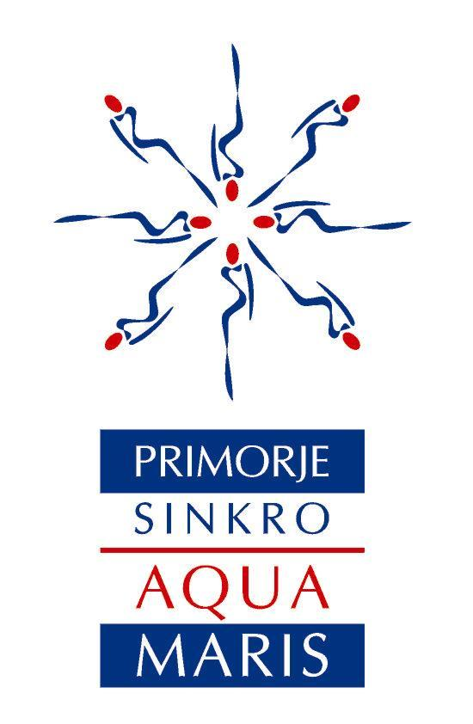

ARTISTIC SWIMMING

INVITATION

21st PRIMORJE SYNCHRO CUP

Rijeka, Croatia

Thursday, June 16th – Sunday, June 19th 2022

Sanja Pavić,
President of the Organising committee

Dear synchro friends!

We cordially invite you to join us on the 21st Primorje Synchro Cup, a competition for juniors, seniors and Age Group 13-15 swimmers. The competition already has an established tradition and regularly attracts numerous European (and world!) synchro enthusiasts.

Moderate climate, seaside location and a modern pool complex which hosted the 2021 1st European Artistic Swimming Age group 13-15 Championships makes participating in this competition a wonderful experience.

We are hoping you will help us share this information and join us for four days of synchro events in Rijeka!

Faithfully yours,

Sanja Pavić

Marko Filipović,
Mayor of Rijeka

Dear friends,

it is a great pleasure to invite you to the 21st Primorje Synchro Cup, a traditional and renowned championship, to be held in Rijeka, Croatia.

This swimming pool complex hosted many great top sport events, and Rijeka has proven more than capable of organizing great sports events, offering best quality services for training camps and important championships.

As the host of this Cup, we are more than certain, that during your stay in Rijeka, you will recognize the high quality of the Kantrida Swimming Pools Complex as well as services offered by everyone involved.

Unique beauty of the landscape and spectacular view, all based on existing natural resources represent a sports destination you will be eager to conquer.

We hope you will join us in Rijeka and become a part of this great synchro event!

Marko Filipović

GENERAL INFORMATION

- Venue
Kantrida Swimming Pool Complex
Rijeka, Podkoludricu 2
(web: www.rijekasport.hr/en/swimming-pools-kantrida)
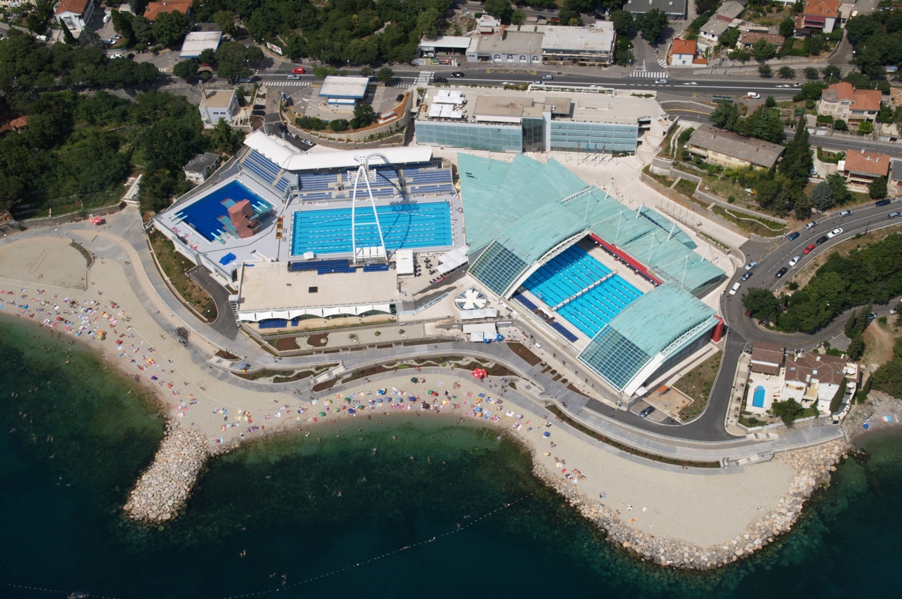
*Indoor pool (mobile roof): Length: 50 m; Width: 25 m; Depth 2,25 m (the pool to the right in the picture above, with open roof)
*Water temperature: 27C; Air temperature: 28C (in case of closed roof)
The Kantrida Swimming Pools sport complex was inaugurated in 2008 and completed in 2011. Pool-wise, the facilities include: Olympic Swimming Pool 1 (indoor swimming pool with a unique retractable roof structure), the reconstructed Olympic Swimming Pool 2 (outdoor swimming pool 50m x 22m; 1,9m depth), a 25m swimming pool, a children’s swimming pool (1,25m depth) and a diving pool.
There are also fitness suites, wellness, scuba diving centre, cafés and parking facilities, all offering a breath-taking view of the Kvarner Bay and the islands.
In earlier years, the venue hosted several international events like the European Short Course Swimming Championships, Synchronised Swimming CO.ME.N. Cup, LEN Final Four Water Polo, European Junior Water Polo Championships, as well as many national and international Synchronised Swimming, Water polo, Swimming and Diving championships and tournaments European artistic swimming championship for age group 13-15.
Right next to the complex is a beach, which was officially opened to the public in June 2011.
- Event contact
SYNCHRONIZED SWIMMING CLUB

„PRIMORJE AQUA MARIS“

KANTRIDA Swimming pools

Podkoludricu 2, 51000 RIJEKA, CROATIA

Tel. /fax: ++385 51 621 682

e - mail: primorje.sinkro@gmail.com
web: http://www.primorje-sinkro.hr/primorje-synchro-cup/
Klub sinkroniziranog plivanja Primorje Aqua Maris

- Participation
The competition is open to national teams and clubs for (FINA rule ASAG 2):

- Seniors (swimmers born in 2006 and older)
- Juniors (swimmers born in 2004 - 2007)
- Age group 13-15 (swimmers born in 2007 - 2009)

NEW!!! With the trend of new rules, we are opening this competition for MALE SOLO in all categories!
Each competitor's identity and date of birth will be checked according to LEN Rule E 14.5
Each national team or club is allowed to take part with:
- 2 solos female & male
- 2 duets
- 1 mixed duet
- 1 team
- 1 free routine combination
- 1 highlight
- 12 swimmers for each age category (14 with mix duet)
Depending on the number of participating swimmers, fed/club should bring judges according to the following rules:
- 4 to 10 swimmers - (at least) 1 judge
- 11 to 20 swimmers - 2 judges
- over 20 swimmers - 3 judges
All judges will be evaluated by an official FINA/LEN evaluator.
- Rules and Results
The competition will be held according to these rules and FINA rules (2017/2021);
An exception to the FINA rules is:
AS 4.4 - Free Combination can have 5-10 swimmers in the team
There will be DIRECT FINALS for all events (all routines will be performed once);
The results will be calculated according to the percentages allocated to each session:
AG13-15 (6 medal events): figures 100% + solo free F and M 100%
figures 100% + duet free 100%
figures 100% + mix duet free 100%
figures 100% + team free 100%
free routine combination 100%

Juniors (12 medal events): solo tech F and M 100%
duet tech 100%
mixed duet tech 100%
team tech 100%
solo free F and M 100%
duet free 100%
mixed duet free 100%
team free 100%
free combination 100%
highlight routine 100%

Seniors (12 medal events): solo tech F and M 100%
duet tech 100%
mixed duet tech 100%
team tech 100%
solo free F and M 100%
duet free 100%
mixed duet free 100%
team free 100%
free combination 100%
highlight routine 100%

- Medals and Prizes
Places 1-3: medals
Overall winning federation/club: "Primorje Cup" total winner trophy.

- Entries
Entries should be made as soon as possible, bearing in mind the deadlines below:
- March, 01st 2022 Preliminary Entry Form
Preliminary accommodation
- June, 01st 2022 Final accommodation
- June, 01st 2022 Music files sending (FINA rules AS 15.3; Method 2)
- June, 01st 2022 Final Entry Form
The second announcement, containing Final Entry Form and Final accommodation Form, will be mailed to all participants after receiving the Preliminary Entry Form
- Entry Fee
Date of payment May, 30th & BEFORE June, 01st and after
(not the date of sending the final entry form)

FIGURES 10 EUR/competitor 13 EUR/competitor
SOLO / Tech SOLO 15 EUR/each start 20 EUR/each start DUET / Tech DUET 20 EUR/each start 26 EUR/each start MIXED DUET/Tech MIXED DUET 20 EUR/each start 26 EUR/each start TEAM / Tech TEAM 30 EUR/each start 39 EUR/each start COMBO 30 EUR/each start 39 EUR/each start
HIGHLIGHT 30 EUR/each start 39 EUR/each start

- Entry Forms & Other Information
All the forms can be downloaded from:
http://www.primorje-sinkro.hr/primorje-synchro-cup/21th-primorje-synchro-cup/

- Preliminary Info about Program
According to the number of entries, the competition will start on Thursday, June 16th or Friday, June 17th.
The preliminary program will be sent to you and published on the official website after June 1st 2022.
June, 16th registration
Thursday judges meeting
team managers meeting

June, 17th competition
Friday

June, 18th competition
Saturday opening ceremony

June, 19th competition
Sunday victory ceremony
closing (about 14:00)

NOTE: The schedule is preliminary and the changes of schedule will be sent after the final entry deadline.

How to Reach Rijeka
(see more about Rijeka on Wikipedia: https://en.wikipedia.org/wiki/Rijeka)
The city's own international airport, Rijeka Airport, is located on the nearby island of Krk across Krk Bridge. Buses, with a journey time of approximately 45 minutes, operate from Rijeka city center and nearby Opatija, with a schedule based on the planned arrival and departure times of flights. Alternative nearby airports include Pula (about 90 minutes drive from Rijeka), Trieste (about 90 minutes), Ljubljana (about 2 hours), Zagreb (about 2 hours) and Venice (about 3 hours).
Rijeka has efficient road connections to other parts of Croatia and the surrounding countries; the A6 motorway connects Rijeka with Zagreb via the A1, while the A7 motorway, completed in 2004, takes you to the Slovenian border continues to Ljubljana (via Postojna) or with Trieste, Italy. The A7 acts as the Rijeka bypass motorway and facilitates access to the A8 motorway of the Istrian Y network starting with the Učka Tunnel, and linking Rijeka to Istria.
Rijeka is integrated into the Croatian railway network and international rail lines. A fully electrified railway connects Rijeka to Zagreb and beyond, towards the Hungarian border as part of Pan-European corridor Vb. Rijeka is also connected to Trieste and Ljubljana by a separate electrified line that extends northwards from the city. Rijeka has daily direct connections by train to Vienna, Munich, and Salzburg, and night trains running through Rijeka.

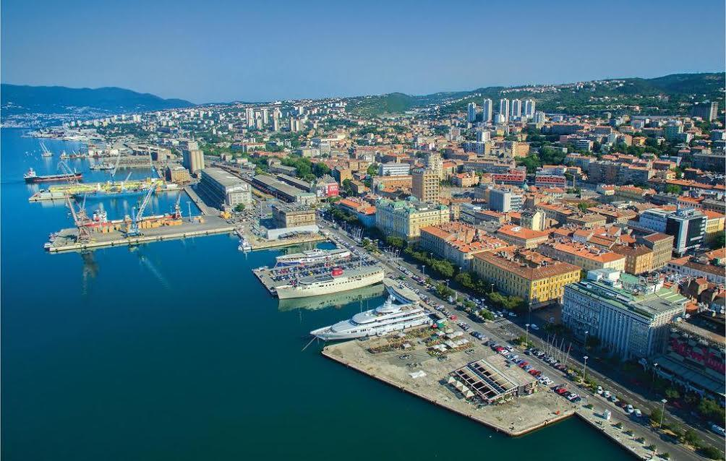

Have a nice time in Rijeka!!!

